**CHARGE IN ADVANCE**

* **TO START,  
  1.) Menu**

Menu

Charge In Advance

Transactions

**2.) Transactions  
3.) Charge In Advance**

11*1*

31*1*

21*1*

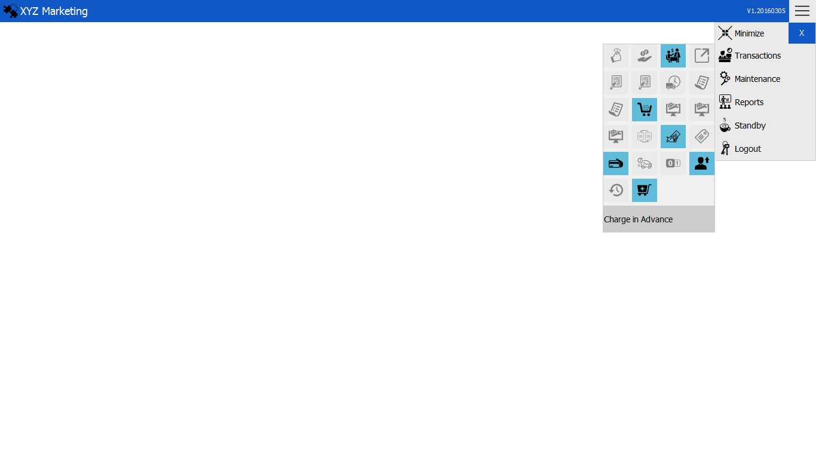

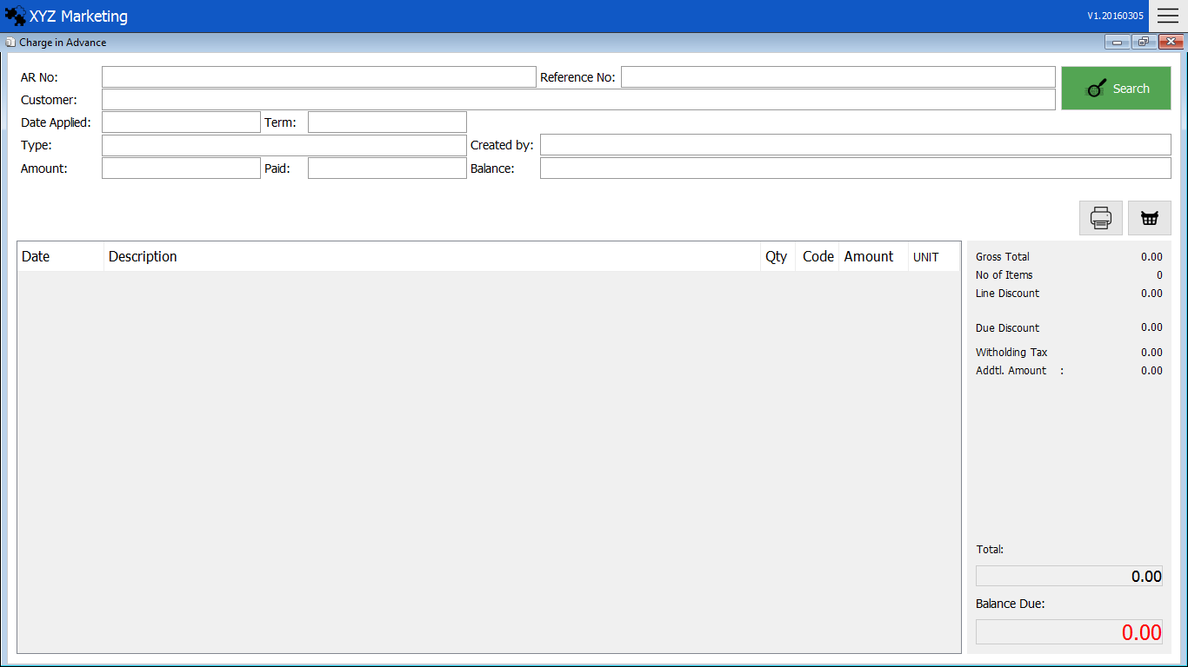

Print Preview

Add Item

Transaction Details

Search

11*1*

**1.) Search & add item**

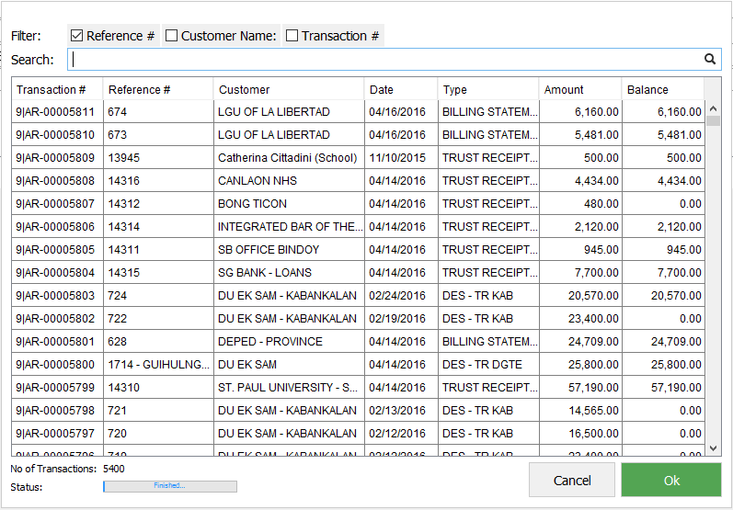

You can search transactions by using  
a.) Reference No.  
b.) Customer’s Name  
c.) Transaction No.   
Click button Ok when finish searching

List of Transactions

Search Box

Search Filter

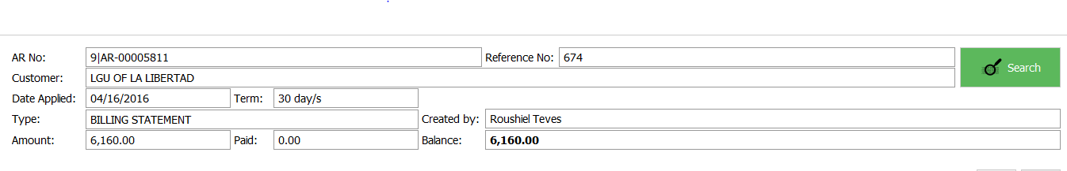

You can see the details of the transaction and you can add item on the transaction.

**1.2.) Adding Item**

Press the Add item button to add item on the transaction.

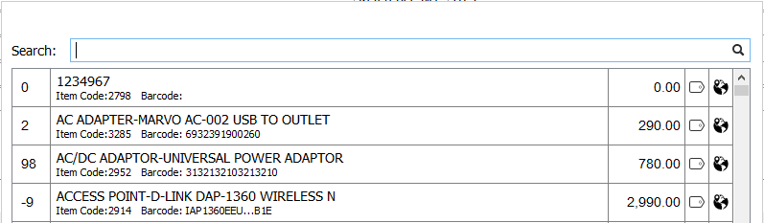

Search item in the search box and click the item you want to add.

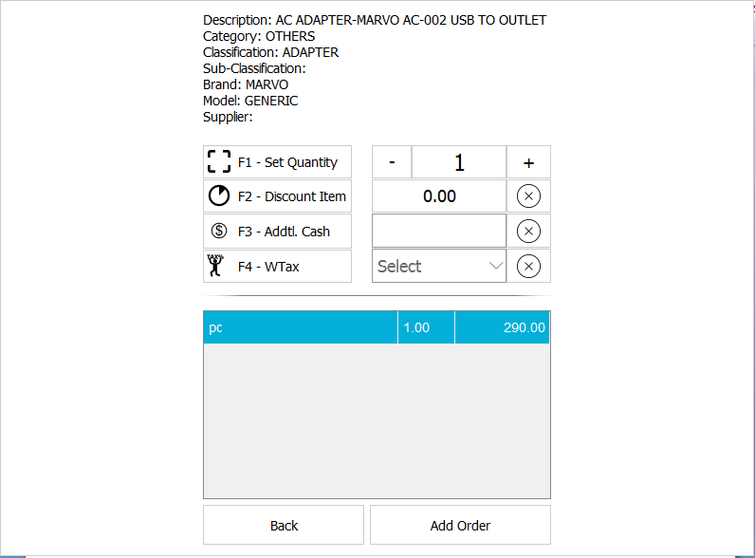

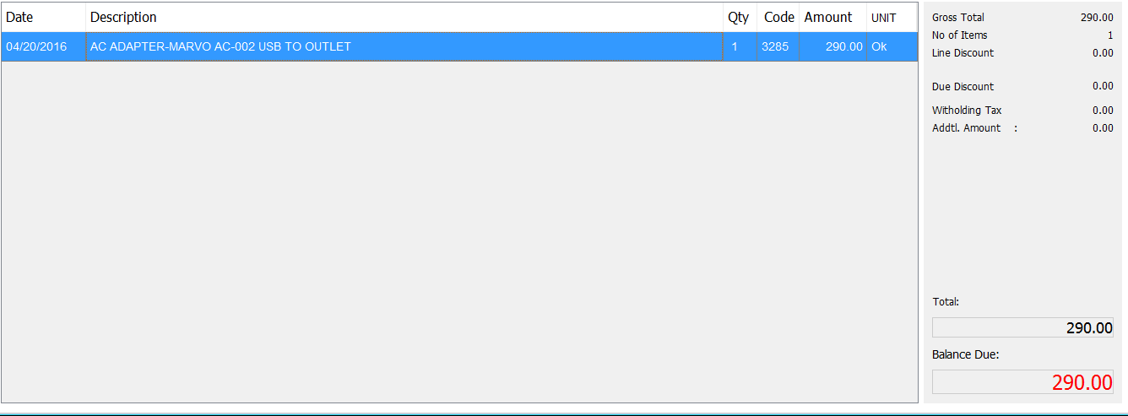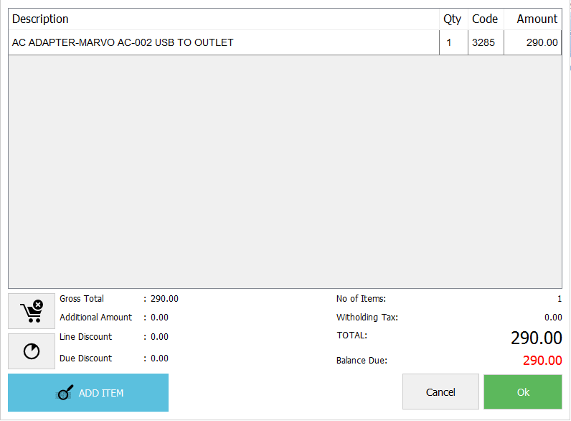

The Details will show after clicking add order and if done click ok to finish.

Add Item

Discount Item

Remove Items

Fill up the details and Add order to finish.

The Item is added to the account

**PRINT PREVIEW**

Click the Print Preview button to show to the added item and other details.

